Key Elements

- Political Effects
- Laws and regulations
- Environmental effects
- IT development
- Competitors and their intentions
- Market trends and requirements
- New technologies, services and ideas
- Key contracts and partnerships
- Maintenance of internal capacity
- Tackling the barriers
- Unbeatable obstacles
- Losing key personnel
- Adequate financial support
- Economy, nationally and internationally
- Season, weather effects
Key Elements
- Disadvantages of business
- Lack of skills
- Lack of competitive advantage
- Reputation, presence and ability to reach the market
- Finance and Economics
- Known weaknesses
- Time schedules, deadlines and requirements
- Cash flow, lack of current assets at start
- Continuity, weaknesses in the supply chain
- Weaknesses in the core business, lack of resources
- Achievement and schedules
- Perseverance in morale and leadership
- Lack of certifications and qualifications
- Processes, systems, IT
- Leadership
Key Elements

- Benefits of the business
- Capabilities
- Competitive Advantages
- Unique qualities for sale
- Resources, people and assets
- Experience, knowledge, data
- Financial resources, the possibility of profit
- Marketing - distribution, awareness and position
- Innovative aspects
- Location and geography
- The price, value, quantity
- Qualifications and certifications
- Processes, systems, IT, communications
- Culture, attitudes, behavior
- Management, continuation, control
- Philosophy and Values
www.skape.no – for business startup in Rogaland 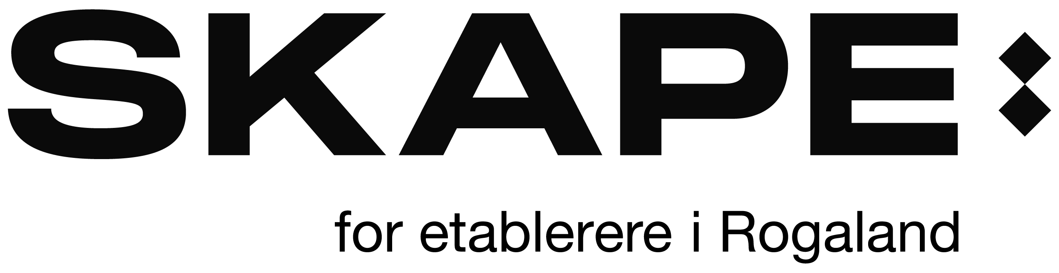
Strengths
Weaknesses
Opportunities
Threats
Key Elements

- Market Development
- Weaknesses of Competitors
- Market and lifestyle trends
- Technological development and innovation
- Global Influence
- New markets
- Niche Market
- Geography, export, import
- Unique qualities for sale
- Tactic: surprise, major contracts
- Business and Product Development
- Information and research
- Partnership, agents, distribution
- Volume, production, finance
- Season, weather, fashion trends and other market trends

SWOT Analyses

Analyses of the following business: ____________________________________________________________________________________________________________

(This SWOT analyses is for the startup of a new business)

